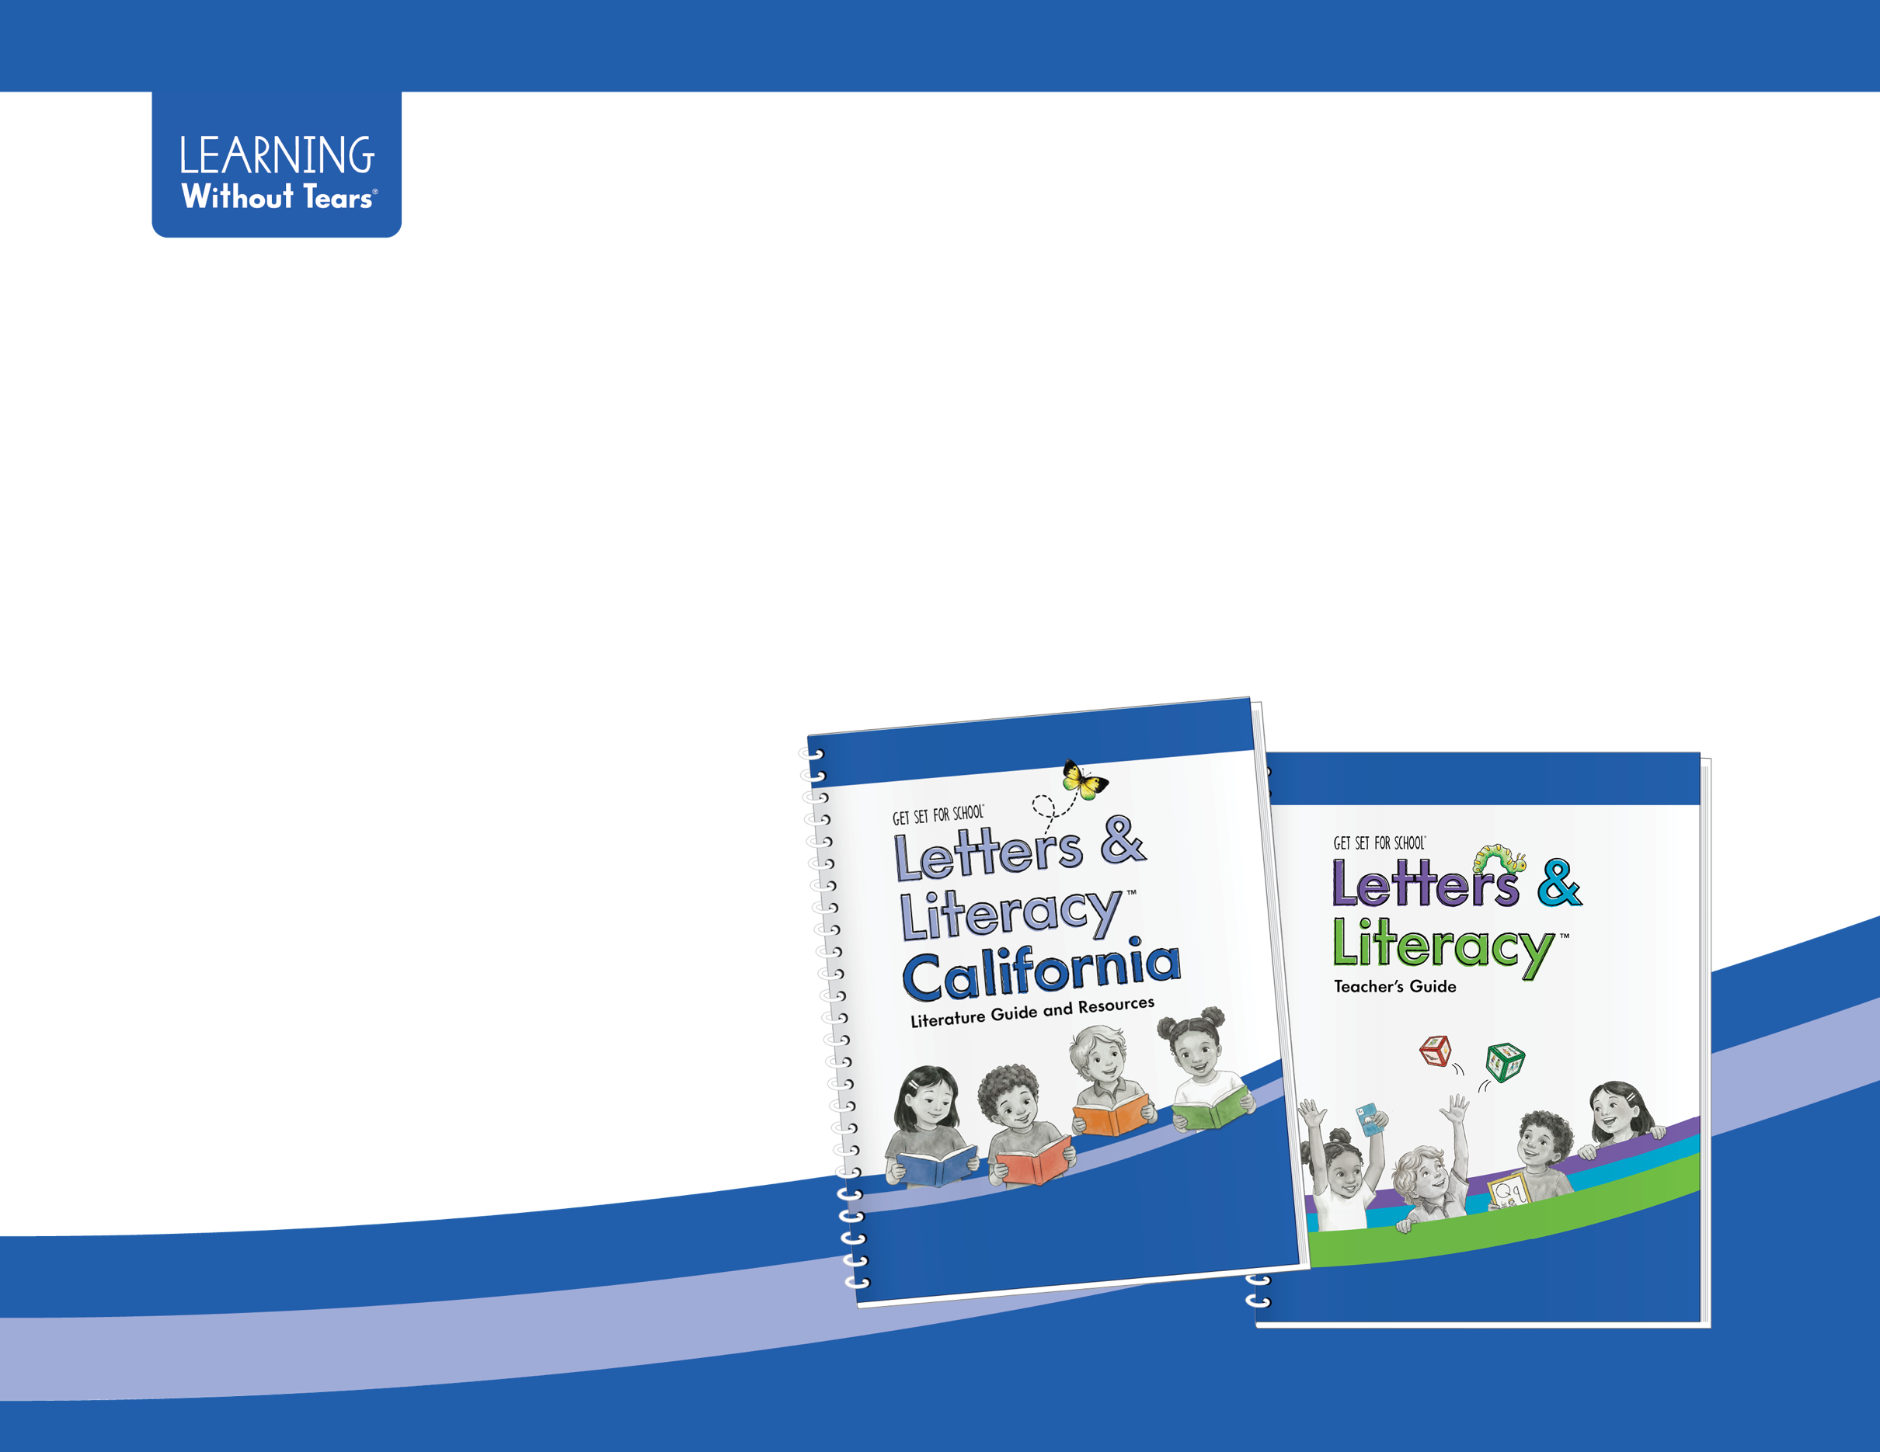

Easy Steps to Review Letters & Literacy™ California
ELA Foundations Map
Program 6.1: Transitional Kindergarten
ELA Foundations Map for Program 6.1: Transitional Kindergarten
Refer to Letters & Literacy California Literature Guide and Resources and Letters & Literacy Teacher’s Guide, both available in print.
Some lessons reference resources that are located in the Interactive Digital Teaching Tool™ (IDTT). Use these links to review.
Access the California Reviewer Page: | Interactive Digital Teaching Tool (IDTT):
- LWTears.com/CA2026  - Evaluation Criteria Map 6.1  - ELA Foundations Map 6.1 | - Assessment to Guide Instruction (AGI)  - Across Languages: Phonemes  - Articulation Videos  - Reproducible Letter Books  - Songs

Use the following key to locate the information needed to review the program.
CALTG: Letters & Literacy California Literature Guide and Resources | LLTG: Letters & Literacy Teacher’s Guide
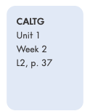  - Unit  - Week  - Lesson (L)  L1: Introduction to Text  L2: Vocabulary or Letter Learning  L3: Making Meaning  L4: Extend and Apply Learning  L5: Optional Lesson | 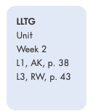  - Unit  - Week  - Lesson (L)  L1: Lesson 1  L2: Lesson 2  L3: Lesson 3  L4: Lesson 4  L5: Review or Progress Monitoring  - PA: Phonological Awareness  - AK: Alphabet Knowledge  - RW: Readiness & Writing

Publisher/Developer: Learning Without Tears  Program Title: Get Set for School: Letters and Literacy ™ California  Components: Letters & Literacy™ California Classroom Kit | Approved by the State Board of Education on November 6, 2025  Page 3 of 19

English Language Arts Foundations Map for Program 6: Basic English Language Arts (6.1), Basic English Language Arts/English Language Development Transitional Kindergarten (6.2), Basic Biliteracy Transitional Kindergarten (6.3) Learning Foundations

Strand: 1.0 Listening and Speaking

Sub-Strand: Vocabulary
Foundation | Foundation Language | Publisher/Developer Citations | Met  Yes | Met  No | Reviewer Comments, Citations, and Questions
TK.LS1.1 | Understand and use an increasing variety of words for objects, actions, and attributes experienced in everyday life, such as through play, conversations, or stories. | CALTG, Unit 1  Week 2 ,Vocabulary Chart, L2, L4 pp. 24–25  Unit 3 Week 18  Vocabulary Chart, L2, L4, pp. 74–75  Unit 5 Week 28  Vocabulary Chart, L2, L4, pp. 118–119  LLTG, Unit 1 Week 1 L1, PA, p. 28, L3, PA, p. 32  Week 5 L4, AK, p. 74  Week 6 L1, RW, p. 79 | For reviewer use only. | For reviewer use only. | For reviewer use only.
TK.LS1.2 | Understand and use increasingly specific vocabulary to describe categories and the relationships within them. | CALTG, Unit 1  Week 2 L2, L3, L4,  p. 25  Unit 3 Week 16  L2, L3, L4, p. 65  LLTG, Unit 1 Week 2  L1, PA, p. 38  L1, AK, p. 38  L3, AK, p. 40  Week 3 L2, AK, p. 50  Week 5 L4, AK, p. 74  Week 6 L2, RW, p. 81  Unit 3 Week 15 L4, RW, p. 183 | For reviewer use only. | For reviewer use only. | For reviewer use only.
TK.LS1.3 | Understand and use increasingly specific words to describe and compare the size and location of objects (such as “longer” and “between”). | CALTG, Unit 4 Week 20 Vocabulary Chart, L1–L4, pp. 86–87  Unit 3 Week 14, MLL Supports, p. 5  LLTG, Unit 1 Week 1 L1, RW, p. 29  L2, AK, p. 30  Week 6 L2, p. 81  Unit 2 Week 8 L2,  p. 105 | For reviewer use only. | For reviewer use only. | For reviewer use only.

Sub-Strand: Grammar
Foundation | Foundation Language | Publisher/Developer Citations | Met  Yes | Met  No | Reviewer Comments, Citations, and Questions
TK.LS1.4 | Use both common and less common word forms and sentence forms to express complex thoughts and ideas. | CALTG,Unit 1 Week 5 L3, L4, p. 31  Unit 2 Unit Connections, p. 35  Unit 4 Week 2 L3, L4,  p. 91  Unit 6 Week 36 L1–L4, pp. 136–137  LLTG, Unit 1 Week 2 Weekly Overview: Multilingual Learners,  p. 37  Unit 2 Week 9 L2, RW, Multilingual Learners,  p. 115  Week 11 L3, AK, p. 136 Unit 3 Week 15 Weekly Overview: Multilingual Learners, p. 175  Unit 4 Week 19 L1, AK, p. 220  Unit 5 Week 25 L1, AK, p. 285  Week 27 L3, AK, p. 308 Unit 6 Week 34 L4, PA, p. 385 | For reviewer use only. | For reviewer use only. | For reviewer use only.

Sub-Strand: Language Use

Foundation | Foundation Language | Publisher/Developer Citations | Met  Yes | Met  No | Reviewer Comments, Citations, and Questions
TK.LS1.5 | Use questions and follow-up questions to seek information and to clarify and confirm understanding. | CALTG, Unit 1 Week 5 L1, L3, pp. 30–31  Unit 3 Week 14 L1, L3, pp. 56–57  Unit 5 Week 30 L1, L3, L4, pp.122–123  Unit 6 Week 35 L1–4, pp. 134–135  LLTG, Unit 2 Week 11 Weekly Overview: Multilingual Learners,  p. 131  Unit 3 Week 15 Weekly Overview: Multilingual Learners, p. 175 | For reviewer use only. | For reviewer use only. | For reviewer use only.
TK.LS1.6 | Use language to construct real or fictional extended narratives that have several details or a plotline. | CALTG, Unit 2 Week 12 L3, L4, p. 47  MLL Supports, p. 46 Unit 3 Week 17 L4,  p. 67  MLL Supports, p. 66 Week 18 L3, L4, p. 71 Unit 4 Week 20 L3, L4, p. 81  Unit 6 Week 32 L1, L4, pp. 128–129 | For reviewer use only. | For reviewer use only. | For reviewer use only.
Foundation | Foundation Language | Publisher/Developer Citations | Met  Yes | Met  No | Reviewer Comments, Citations, and Questions
TK.LS1.7 | Share detailed descriptions, opinions, and explanations. | CALTG,  Unit 1 Week 6 L1, L3, pp. 32–33  Unit 2 Week 8 L1, L3,  p. 38–39  Unit 4 Unit Overview: Classroom Connections, p. 77 Week 22 L1, L3,  pp. 92–93  Week 24 L3, p. 101  Unit 6 Week 34 L1–4 Lit, pp. 132–133  LLTG,  Unit 1 Week 2 Weekly Overview: Multilingual Learners, p. 37  Week 2 L4, AK, p. 44 Week 5 L4, AK, p. 74 Unit 3 Week 16 L4, RW, p. 193  Unit 6 Week 30 L1, AK, p. 334 | For reviewer use only. | For reviewer use only. | For reviewer use only.
TK.LS1.8 | Participate in increasingly long and complex back-and-forth conversations with adults and peers. Respond on topic across several turns in the conversation. | CALTG,  Unit 3 Unit Overview: Classroom Connections, p. 49 Week 13 L4, p. 51 Week 15 L1, Lit, p. 58 Unit 5 Unit Overview: Classroom Connections, Lit, p. 107 Week 25 L4, p. 109 Week 30 L4, p. 123  Unit 6 Unit Overview: Classroom Connections, p.125 Week 35 L1, p. 134  LLTG, Oral Language and Pre-Writing Supports, p. 417  Unit 4 Week 21 L4, RW, p. 247  Week 22 L4, RW,  p. 257  Week 24 L4, RW,  p. 277 | For reviewer use only. | For reviewer use only. | For reviewer use only.

Strand: 2.0 Foundational Literacy Skills

Sub-Strand: Phonological Awareness
Foundation | Foundation Language | Publisher/Developer Citations | Met  Yes | Met  No | Reviewer Comments, Citations, and Questions
TK.FLS2.1 | Isolate and pronounce the first sound of a word, with adult support or the support of pictures or objects. | CALTG, Unit 3 Week 15 L2, L4, p. 59  LLTG, Unit 2 Week 11 L1, PA, p. 132, L4, PA, p. 138  Unit 3 Week 13 L3, RW, p. 161 Week 16 L2, PA, p. 188  Week 21 L3, PA, p. 244  Unit 4 Week 19 L2, PA, p. 222 Week 21 L3, PA, p. 244 Unit 6 Week 34 L3, PA, p. 382, L4, PA, p. 384 | For reviewer use only. | For reviewer use only. | For reviewer use only.
TK.FLS2.2 | When presented with syllables and individual sounds, blend them into words in speech with adult support or the support of pictures or objects. | CALTG, Unit 3 Week 15 L4,  p. 61  Unit 5 Week 25 L4, p. 111  LLTG, Unit 2 Week 7 L1, PA,  p. 92, L3, PA, p. 96, L5, PA,  p. 100  Unit 2 Week 1 L5, PA, 120  Unit 3 Week 20 L3, PA, p. 234 Unit 4 Week 23 L3, PA, p. 264 Week 24 L4, PA, p. 270  Unit 5 Week 26 L3, PA, p. 298, L4, PA, p. 300  Week 27 L1, PA, p. 304 L3, PA, p. 318  Unit 5 Week 30 L1, PA, p. 334 L4, PA, p. 340 | For reviewer use only. | For reviewer use only. | For reviewer use only.
TK.FLS2.3 | Not applicable |  | For reviewer use only. | For reviewer use only. | For reviewer use only.

Sub-Strand: Alphabetics and Print
Foundation | Foundation Language | Publisher/Developer Citations | Met  Yes | Met  No | Reviewer Comments, Citations, and Questions
TKFLS2.4 | Match many letter names to their printed form.  If learning the alphabet in English, Spanish, or other languages using a similar alphabet, such as Tagalog, match most (about 15 to 20) uppercase letter names and approximately half (about 12 to 16) of the lowercase letter names to their printed form. | CALTG, Unit 1 Week 1 L2,  p. 23  Unit 3 Week 13 L4, p. 53  Unit 6 Week 36 L2, L4, p. 137  LLTG, Unit 1 Week 3 L1, AK,  p. 48  Unit 2 Week 9 L2, AK, p. 114, L4, AK, p. 118, L4, RW, p. 119 Unit 4 Week 22 L2, AK, p. 252, L2, RW, p. 253  Unit 5 Week 25 L1, AK, p. 284 Week 26 L2, AK, p. 296, L2, RW, p. 297 | For reviewer use only. | For reviewer use only. | For reviewer use only.
TK.FLS2.5 | Accurately identify or produce sounds associated with several letters or common characters with adult support. If learning the alphabet in English, Spanish, or other languages using a similar alphabet, such as Tagalog, accurately identify or produce sounds associated with about half of the letters. | CALTG, Unit 2 Week 12 L1–L4, pp. 46–47 Unit 4 Week 20  L1–L4, pp. 84–85  Unit 6 Week 36 L1–L4,  pp. 136–137  LLTG, Unit 2 Week 2 L2, AK,  p. 144 L2, RW, p. 145 L3, AK, p. 146 L3, RW, p. 147  Unit 3 Week 17 L3, AK, p. 200, L4, AK, p. 202  Unit 4 Week 19 L1, AK, p. 220 Unit 5 Week 29 L3, AK, p. 328, L4, AK, p. 330 | For reviewer use only. | For reviewer use only. | For reviewer use only.

Sub-Strand: Concepts About Print
Foundation | Foundation Language | Publisher/Developer Citations | Met  Yes | Met  No | Reviewer Comments, Citations, and Questions
TK.FLS2.6 | Identify the meaning of a few instances of familiar print in the environment. | CALTG, Unit 1 Week 1 L2,  p. 23  Unit 2 Week 8 L2, p. 39  Unit 3 Week 17, L2, p. 67  LLTG, Unit 1 Week 1 Preparation, p. 26  Week 3 Weekly Opener, p. 47 Week 4 AK, p. 60  Week 5 L2, AK, Extension,  p. 70  Unit 2 Week 7 L1, AK, p. 92 L3, AK, p. 96  Week 10 L3, AK, p. 126  Week 11 L2, AK, p. 134  Unit 3 Preparation, p. 154 Week 14 L1, AK, p. 166  Week 16 L2, AK, p. 188  Week 19 L2, AK, p. 222  Unit 5 Week 26 L5, AK, p. 302 | For reviewer use only. | For reviewer use only. | For reviewer use only.
TK.FLS2.7 | Display increasingly sophisticated book handling behaviors and knowledge of print conventions, such as turning pages one at a time and understanding the direction and orientation of print. | CALTG Unit 1 Week 5 L1, p. 30 Unit 2 Week 7 L1, L2, L3, pp. 36–37 Unit 4 Week 19 L1, p. 80 Unit 5 Week 30 L1, L2, pp. 122–123 Unit 6 Week 35 L1–L4, pp. 134–135 Week 36 L1–4, pp. 136–137  LLTG Unit 1 Week 1 L3, AK, p. 32 L4, AK, p. 34 Week 3 L2, AK, p. 50 Unit 2 Week 7 L1, RW, p. 93 Unit 6 Week 36 L1, AK, p. 398 L4, AK, p. 404 L4, RW, p. 405 | For reviewer use only. | For reviewer use only. | For reviewer use only.

Strand: 3.0 Reading
Sub-Strand: Literacy Interest and Response
Foundation | Foundation Language | Publisher/Developer Citations | Met  Yes | Met  No | Reviewer Comments, Citations, and Questions
TK.R3.1 | Demonstrate interest in and engagement with literacy and literacy-related activities for progressively extended periods of time and with increasing independence. | CALTG, Unit 1 Unit Overview: Classroom Connections, p. 21 Week 3 L1, L4, pp. 26–27 Week 6 L1, L4, pp. 32–33  Unit 2 Week 11 L3, L4, p. 45 Unit 3 Week 13, MLL Broadening Support, Lit, p. 52, L4, Lit, p. 53  Unit 4 Week 22 L4, p. 95  Week 24 L4, p. 103  Unit 5 Unit Overview: Classroom Connections, p. 107 Week 25 L4, p. 111  Unit 6 Unit Overview: Classroom Connections, p. 125 Week 35 L3, L4, p. 135 | For reviewer use only. | For reviewer use only. | For reviewer use only.

Sub-Strand: Comprehension and Analysis of Age-Appropriate Text
Foundation | Foundation Language | Publisher/Developer Citations | Met  Yes | Met  No | Reviewer Comments, Citations, and Questions
TK.R3.2 | Demonstrate understanding of details in a story, including knowledge of characters, events, and ordering of events, and use their increased understanding of story structure to predict what might come next when asked. | CALTG, Unit 1 Week 3 L1, L3, pp. 26–27  Week 5 L1, L3, pp. 30–31  Unit 2 Week 11 L1, L3, pp. 44–45  Week 12 L1, L3, pp. 46–47  Unit 3 Week 13 L1, L3, pp. 52–53  Week 14 L1, L3, pp. 56–57  Unit 4 Week 22 L1, L4, pp. 92–93  Week 24 L1, L3, pp. 100–101 Unit 5 Week 25 L1, L3,  pp. 110–111 | For reviewer use only. | For reviewer use only. | For reviewer use only.
TK.R3.3 | Demonstrate deeper understanding of informational text using their abilities to make connections to previous knowledge, make inferences, and ask questions. | CALTG, Unit 2 Week 8 L1, L3, pp. 38–39  Unit 3 Week 16 L1, L3, pp. 64–65  Week 18 L1, L3, pp. 74–75  Unit 4 Week 20 L1, L3, pp. 86–87  Week 24 L1, L3, pp. 104–105 Unit 5 Week 27 L1, L3,  pp. 116–117  Week 30 L1, L3, pp. 122 –123  LLTG, Unit 2 Week 8 L3, RW, p. 107  Week 11 L1, RW, p. 133  Unit 3 Week 14 L4, RW, p. 173 Unit 4 Week 21 L4, RW, p. 247 | For reviewer use only. | For reviewer use only. | For reviewer use only.
Strand: 4.0 Writing

Sub-Strand: Writing Skills
Foundation | Foundation Language | Publisher/Developer Citations | Met  Yes | Met  No | Reviewer Comments, Citations, and Questions
TK.W4.1 | Adjust grasp and body position for increased control in drawing and writing. | LLTG, Unit 1 Week 4 L2, RW, p. 61  Unit 2 Week 7 L2, RW, p. 95  Week 9 L1, RW, p. 113  Unit 3 Week 15 L2, RW,  p. 179  Week 16  L3, RW, p. 191 Unit 5  Week 27  L1, RW, p. 305  L2, RW, p. 307 | For reviewer use only. | For reviewer use only. | For reviewer use only.

Sub-Strand: Writing as Communication
Foundation | Foundation Language | Publisher/Developer Citations | Met  Yes | Met  No | Reviewer Comments, Citations, and Questions
TK.W4.2 | Write, with adult support, a few recognizable letters that are intended to represent their corresponding sounds. | CALTG, Unit 2 Week 12  L4, p. 47  Unit 3 Week 14 L4, p. 55  Unit 4 Week 23 L4, p. 97  LLTG, Unit 3 Week 21  L4, AK, p. 246  Unit 5 Week 29 L2, RW, p. 327 Unit 6 Week 30 L2, AK, p. 351  Week 32 L2, AK, p. 360  Week 32 L1, RW, p. 359  Week 33 L3, RW, p. 373  Week 34 L2, AK, p. 380 | For reviewer use only. | For reviewer use only. | For reviewer use only.
Foundation | Foundation Language | Publisher/Developer Citations | Met  Yes | Met  No | Reviewer Comments, Citations, and Questions
TK.W4.3 | Demonstrate interest in conveying extended thoughts and ideas in writing, engaging the help of an adult. | CALTG, Unit 2 Classroom Connections, p. 25  Unit 4 Classroom Connections, p. 77  Week 20 L4, Lit, p. 85  Unit 5 Classroom Connections, p. 107  Week 30 L4, Lit, p. 123  LLTG, Unit 1 Week 5  L3, AK, p. 72  Unit 5 Week 29 L1, RW, p. 325 Week 30 L1, RW, p. 335  Unit 6 Week 32 L1, RW, p. 359, L4, RW, P. 365, L1, AK, p. 348  Week 34 L3, RW, p. 379 | For reviewer use only. | For reviewer use only. | For reviewer use only.
Foundation | Foundation Language | Publisher/Developer Citations | Met  Yes | Met  No | Reviewer Comments, Citations, and Questions
TK.W4.4 | Write a few recognizable letters or characters to represent words or ideas. | CALTG, Unit 1 Unit Overview: Classroom Connections, p. 21  Unit 3 Week 14 L4, p. 57  Unit 4 Week 21 L4, p. 89  Unit 5  Unit 6 Week 32 L4, p. 129  LLTG, Unit 5 Week 28  L5, RW, p. 292  Week 30 L4, AK, p. 340  Unit 6 Week 34 L2, AK, p. 380  Week 35 L4, AK, p. 394 | For reviewer use only. | For reviewer use only. | For reviewer use only.
TK.W4.5 | Write own name nearly correctly. | LLTG, Teaching Name Writing, p. 419  Unit 1 Week 4 L3, RW, p. 63 Unit 6 Week 36 L2, RW, p. 401  Unit 2 Week 8 L5, RW, p. 110  Week 10 L3, RW, p. 127  Unit 3 Week 16 L1, RW, p. 187  Unit 4 Week 20 L5, RW, p. 238  Unit 5 Week 25 L1, RW, p. 285  Unit 6 Week 31 L5, RW, p. 356 | For reviewer use only. | For reviewer use only. | For reviewer use only.
California Department of Education, December 2025



